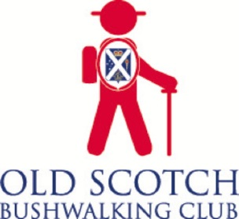
OLD SCOTCH BUSHWALKING CLUB

MEMBERSHIP APPLICATION FORM

$30 PER FAMILY PER YEAR

Membership of the Old Scotch Bushwalking Club is open to all those with an interest in the very enjoyable outdoor activity of walking as part of a group. Although we are very active, we try to avoid organising walks in the ‘difficult’ category.

The club arranges a Sunday walk once a month throughout the year. The program also provides for two weekends away, so we can enjoy two separate days of walking as well as the social side of being together as a group, which makes for some very enjoyable times.

We also organise midweek walks for Wednesdays or Thursdays, once a month. These are usually shorter than our Sunday walks, and mostly in and around the Melbourne suburbs, ending up at a café for lunch or coffee.

Bush walks, beach walks and urban country walks, including winery walks, provide a very interesting mix of places to visit on Sundays. A good pair of walk boots/shoes, a packed lunch and a cheery disposition are all you need.

Our quarterly newsletter – Tracknotes – keeps us informed of what’s happening in the club and when, and includes reports of club events. Also, each member receives a walk notice with full details of the walk a few weeks before its date – usually by email to the member’s listed email address.

Privacy: members can be assured that the membership list (including phone numbers and addresses) will not be used for any purpose other than to help coordinate walks.
______________________________________________________________________

Your details: FIRST NAME SURNAME Mobile No.

Member 1 (Title.……) …………………………………………………………………………….

Member 2 (Title…….)……………………………………………………………………………..

Postal address ……………………………………………………………………………………...

Tel. no.: Home ……………………… Mobile …………………………………………………..

Email …………………………………………………………………………………………………

Do you have ambulance cover? Yes/No Do you have health insurance? Yes/No

If an Old Boy, last year at Scotch …………
____________________________________________________________________________

Postal method:

- Print this page
- Enter your details
- Write a cheque for $30 to:
Old Scotch Bushwalking Club
- And post all to:
- Old Scotch Bushwalking Club
3 Irvine Street
Glen Iris Vic 3146
Email method:

- Enter your details on this sheet
Make EFT payment of $30 to
Old Scotch Bushwalking Club
BSB: 083-277 Account: 463012585
EFT Reference: your surname
- Email this sheet as attachment to:
pn.mcleod@bigpond.com

